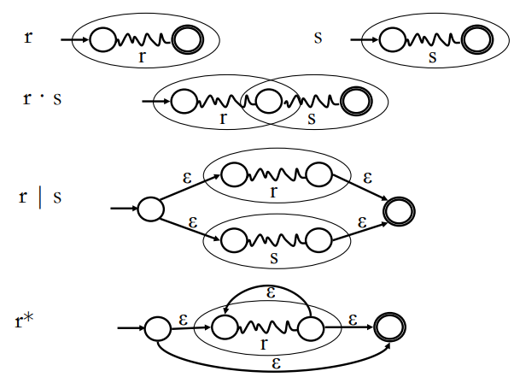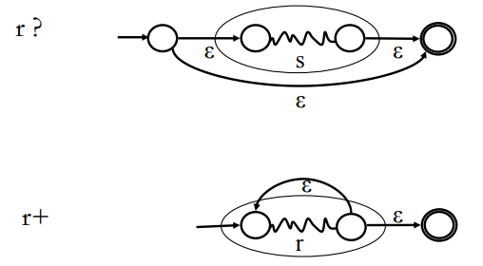

**Thompson’s Construction:**

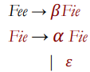

**Eliminating Left Recursion:**

**=>**

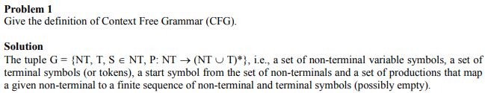

**Context Free Grammar (CFG) Definition:**

**LL(1):**

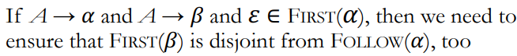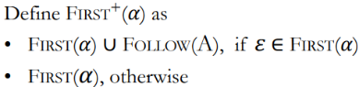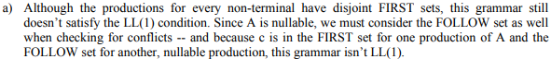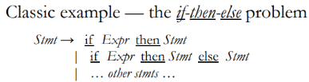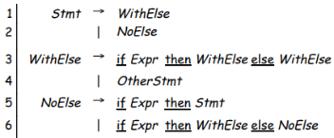

/



**LL parsing (predictive parsing):**

* We write each production N -> α in row N, column t for each t ∈ FIRST(α)
* If α is nullable, we write in row X, column t for each t ∈ FOLLOW(x)
* It is only LL(1) if each table entry has 0 or 1 rules

**Left Factoring:**

**=>**

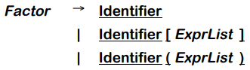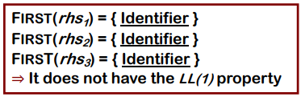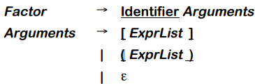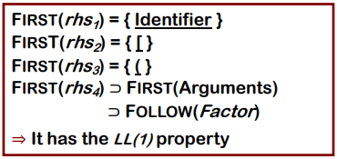

**Embedded Actions:**

**Kleene Construction:**

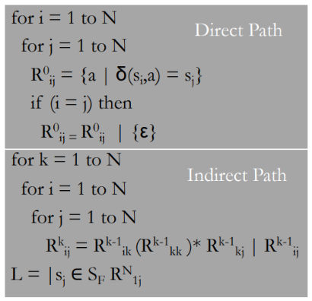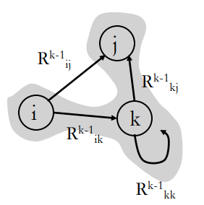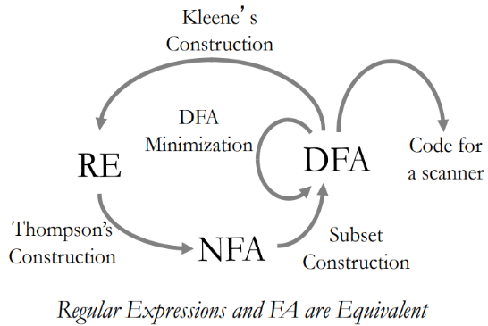

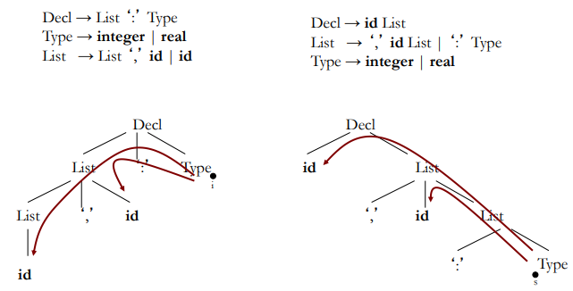

**Replacing Inherited with Synthesized Attrib.:**

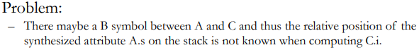

**Inherited Attributes:**

